

**CC4057NI\CC4058NI Introduction to Information System**

**60% Group Coursework**

**2024-25 Autumn**

|  |  |  |  |
| --- | --- | --- | --- |
| **Group Name:** | | | |
| **SN** | **Student Name** | **College ID** | **University ID** |
|  | **Asal Ale Magar** | **NP01AI4A240136** | E.g. 18053646 |
|  | **Pranjal Acharya** | **NP01AI4A240042** | E.g. 18053646 |
|  | **Samrat Sharma** | **NP01AI4A240128** | E.g. 18053646 |
|  | **Nayan Chhyantal** | **NP01AI4A240111** | E.g. 18053646 |
|  | **Aayush Pandey** | **NP01Ai4A240126** | E.g. 18053646 |

**Assignment Due Date: Sunday, January 19, 2025**

**Assignment Submission Date: Sunday, January 19, 2025**

**Word Count: 11350**

*I confirm that I understand my coursework needs to be submitted online via MySecondTeacher under the relevant module page before the deadline in order for my assignment to be accepted and marked. I am fully aware that late submissions will be treated as non-submission and a marks of zero will be awarded.*

**Report on E-commerce Website Development**

**Table of Contents**

1. **Introduction**
2. **Wireframes**
3. **Development**
4. **Content/Design**
5. **Testing**
6. **Conclusion**
7. **References**
8. **Appendices**

**1. Introduction**

In this project, an e-commerce website has been created for a brand name “Urban Watches.” This website is created using HTML, CSS & JavaScript. This project focuses on building an e-commerce website that sells various types of watches. The website includes multiple essential sections:

* **Home Page**: Introduces the store, showcases featured products, and provides easy navigation to other blog section. This home page contains an overall overview of the whole website.
* **Products Page**: The product page of our website displays a collection of watches with details such as prices and specifications. It also showcases all the product available on our website.
* **Blog Page**: The Blog Page shares an insights into the watch industry, including technological advancements and consumer trends over the years.
* **Research Page**: The Research Page compares various features of the website with other e-commerce platforms such as Daraz, NaviForce highlighting unique aspects.
* **About Us Page**: The About Us Page shows the details of the team members behind the project, including their CV and contributions.

The project aims to apply basic web technologies such as HTML,CSS and JavaScript and design principles to deliver a functional, visually appealing, and user-friendly platform.

**Aims and Objectives**

* To design a user-friendly and visually appealing online store.
* Use of wireframes to design the layout and elements of a website.
* Highlight the importance of each technology i.e HTML, CSS and JavaScript, in their own respective ways.
* To demonstrate how technology has influenced the watch industry through blogs and content.
* Test the functionality of a website through various testing methods.
* To showcase the evolution of luxury and smart timepieces with engaging features.
* To compare the platform's features with existing e-commerce websites.
* To provide basic understanding of creation of a website from scratch.
* Mark the importance of documentation, as in providing a proper way of inspection of a specific project.

**Tools Used**

* **HTML5**: HTML stands for Hypertext Markup Language. It creates a complete website structure of web pages. HTML is a combination of Hypertext and Markup language. Hypertext defines the link between the web pages and markup language defines the text document within the tag (GeeksforGeeks, 2024).
* **CSS3**: CSS (Cascading Style Sheets) is used to style web pages. The reason for using this is to simplify the process of making web pages presentable. It allows you to apply styles on web pages. More importantly, it enables you to do this independently of the HTML that makes up each web page. (geeksforgeeks, 2024)
* **JavaScript**: JavaScript (JS) is the most popular lightweight, interpreted compiled programming language. It can be used for both Client-side as well as Server-side developments. It is also known as a scripting language for web pages. (geeksforgeeks, 2024). As a basic requirement, JavaScript was used for form validation and comment boxes with different alert options appearing in different conditions. Making the website more dynamic, image slider with image toggling has been created using JavaScript as well.

**Verdict**

This project has been created using HTML, CSS and JavaScript. The basic layout of our website has been designed using Balsamic Wireframes. In our website, HTML was used for creating the basic structure of every webpage. While we used CSS to style every element accordingly in order to make our webpage more attractive. Additionally, JavaScript was used to make the website more functional and dynamic.

Different testing were also conducted for conclusive examination of the website and its functionality.

**2. Wireframes**

Balsamiq Wireframes is a rapid low-fidelity UI wireframing tool that reproduces the experience of sketching on a notepad or whiteboard but using a computer. (balsamiq, 2024). The main purpose of using a wireframe is to create a layout and to provide a reference when developing a website.

As,Balsamiq is simple to use and very beginner friendly it was used in this project.

**Wireframe Design**

* **Home Page**: Features an overview of the store and links to key sections.
* **Products Page**: Lists watches with relevant details and images.
* **Blog Page**: Includes summaries of the required question i.e.

**→** Explore the impact of technology on the watch industry and consumer trends.

**→**Discuss relevant topics that integrate technological advancements with watch design and sales. Also consists links to detailed articles.

* **Research Page**: Presents comparative analysis with references to other platforms.
* **About Us Page**: Displays team member profiles with information about their roles.

**Comparison and Explanation**

* Wireframes ensure clear navigation and consistency across pages

**HOME PAGE:**

Home page is the first page you encounter when entering the website. In the header, navigation bar is located. It contains links to the rest of the webpages, with suitable logos. The search bar is included with links to the contact and login/signup pages as well. The name of the service with its motto and an art of a printer is shown in the first division. A banner is placed that advertises the service. A division contains short content of the research and blog pages, with respective links. The featured printers currently are shown right below with images, descriptions and a link to view more details about the printer, which takes us to the product details page. Topping it off, links are placed that take us to the portfolio page showcasing every group member with their names and pictures. The footer has the title and the socials of the service, alongside links to the about us, contact and products page annotated suitably. Wireframe and screenshot of the page**:**

**Wireframe:**

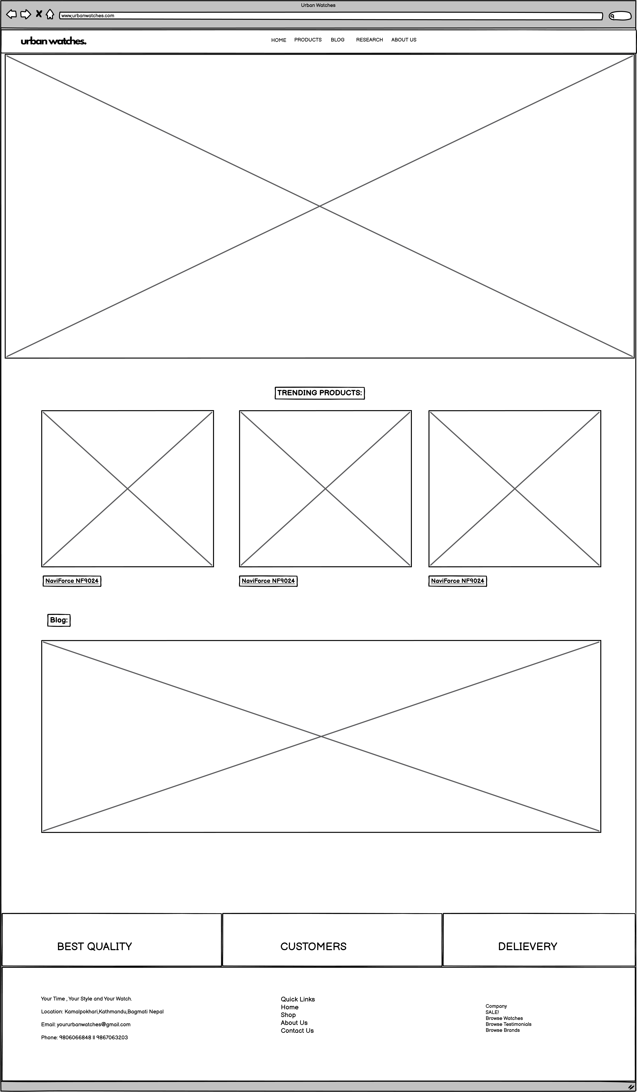

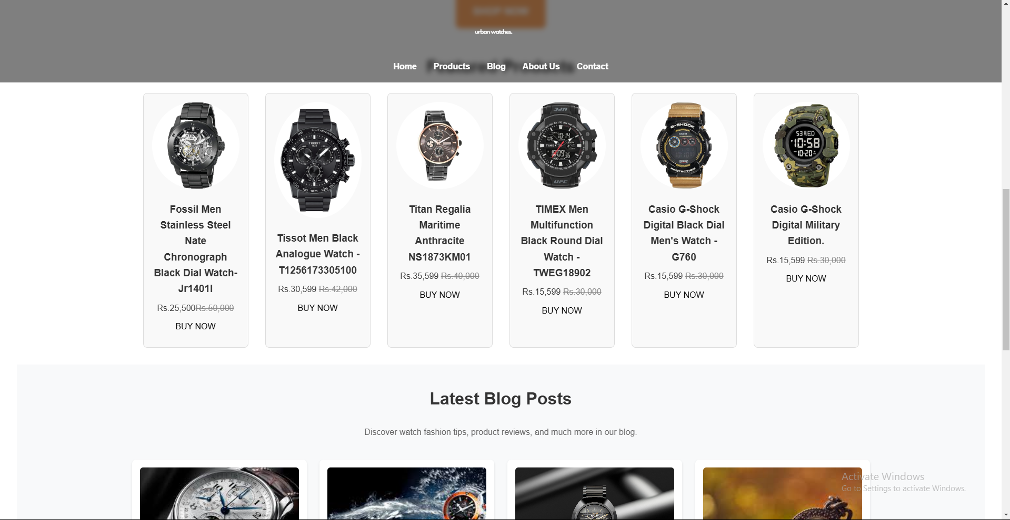**Actual Home Page:  
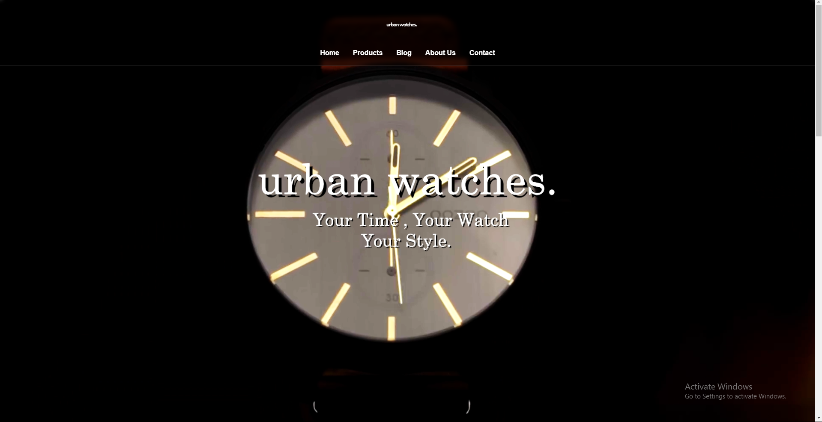**

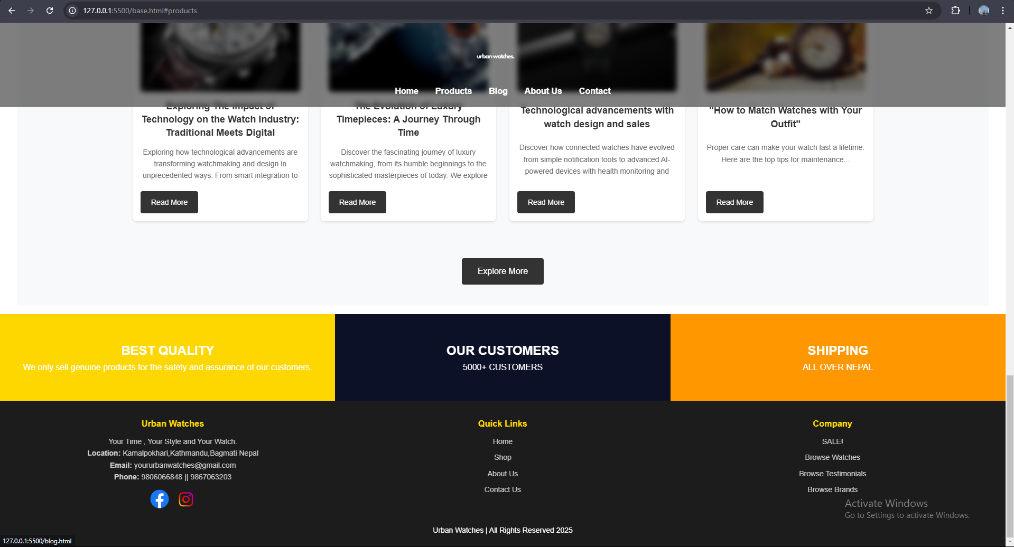

**PRODUCT PAGE:**

Products page can be accessed through the navigation bar, the footer, and details in the home page. In the head, the navigation bar is located. It contains its own navigation bar with links that show details on different categories of printers. Below, an advertisement banner is placed. Every category with an option to view more printers of similar type exists. Every single product has a see more option which when pressed takes us to the product details page. The product details page contains an image slider made using JavaScript. Right to it, are the details of the product with view more button showing the hidden details. It has a buy button which when presses display a popup which confirms the order. Below it there are other printers of the same category. The footer is included.

**Wireframe of Product Page:**

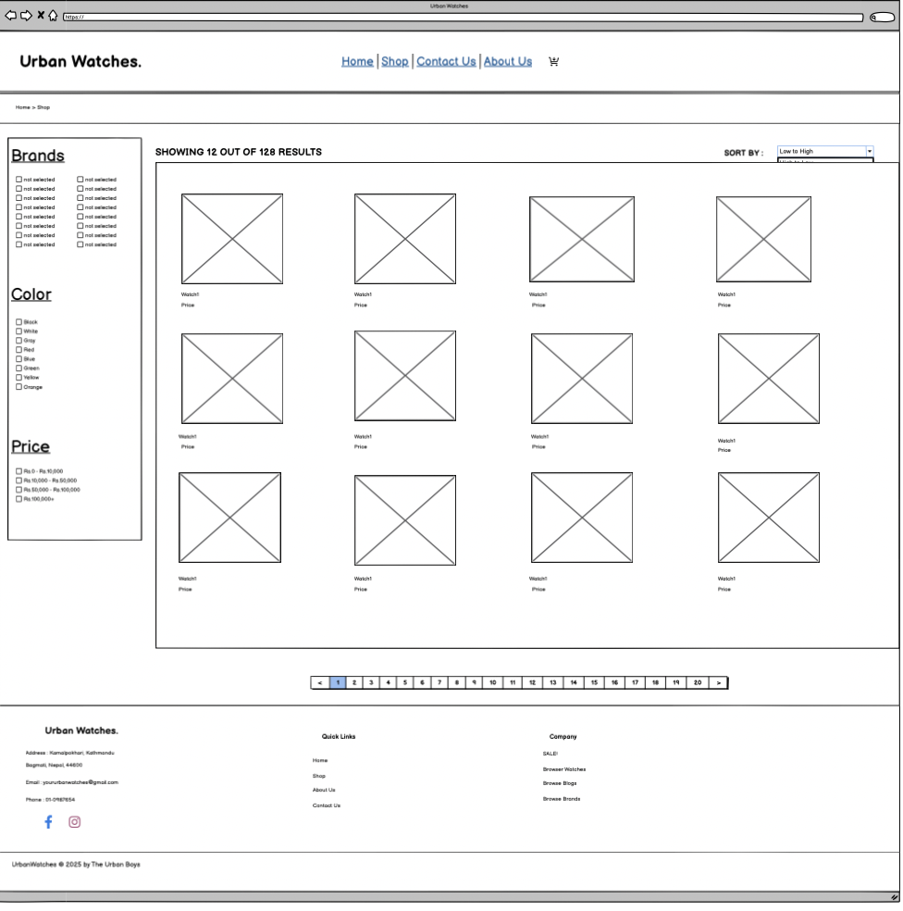

**Actual Product Page:**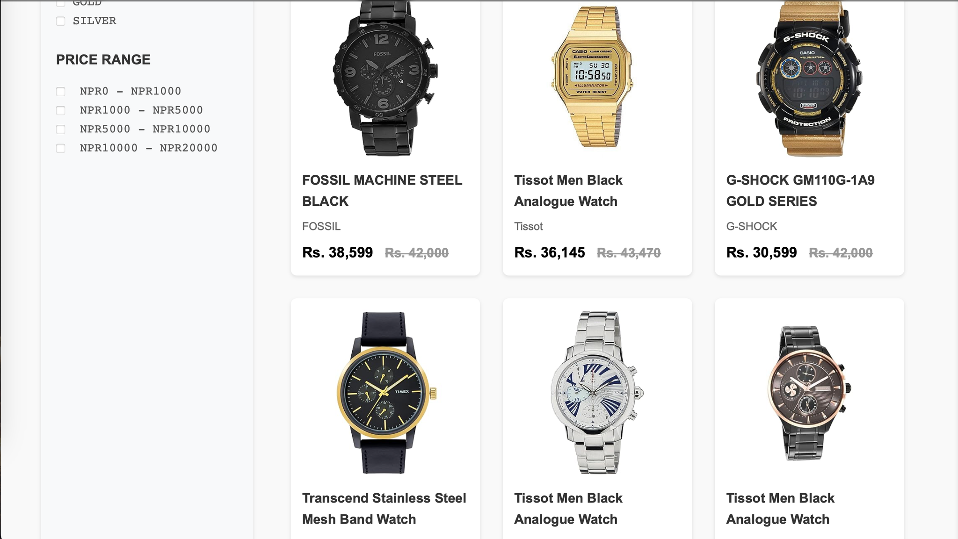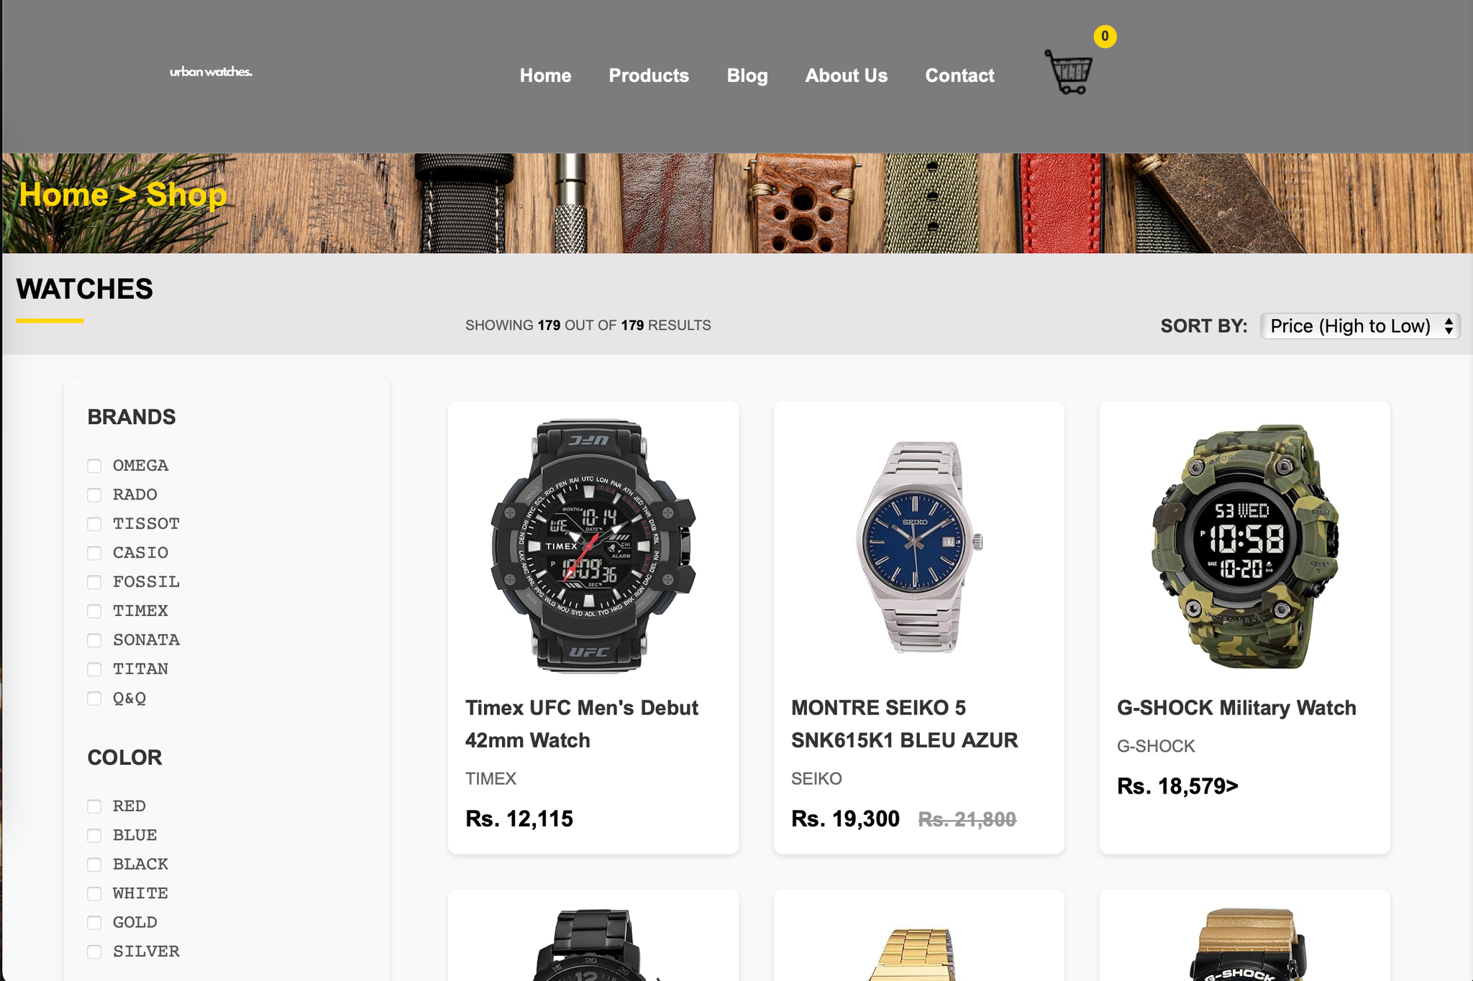

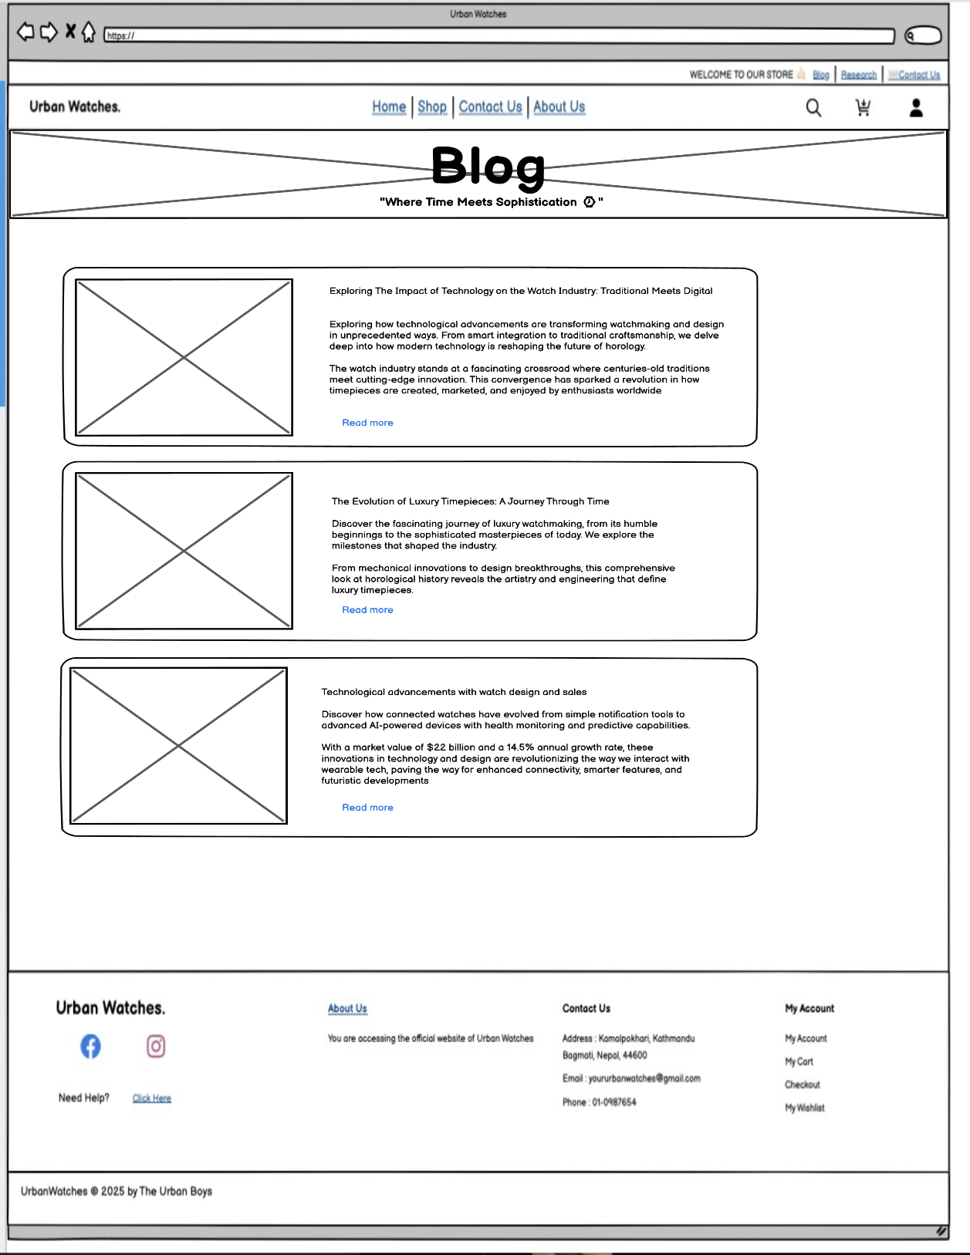**BLOG PAGE:**

:

**Actual Blog Page:**

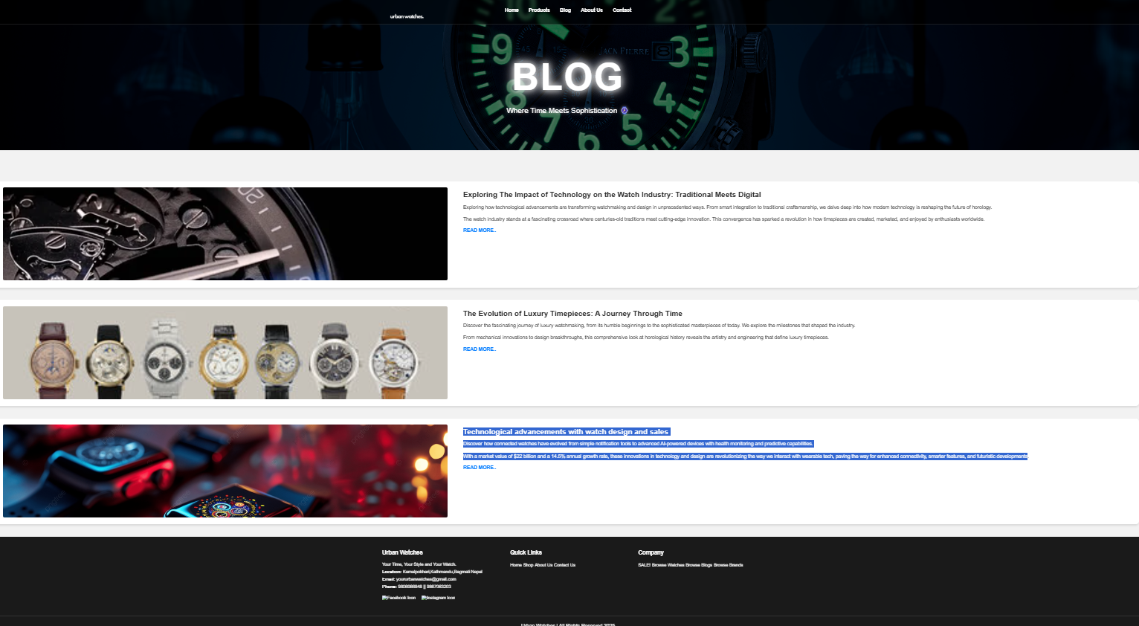

**Contact Us Page:**

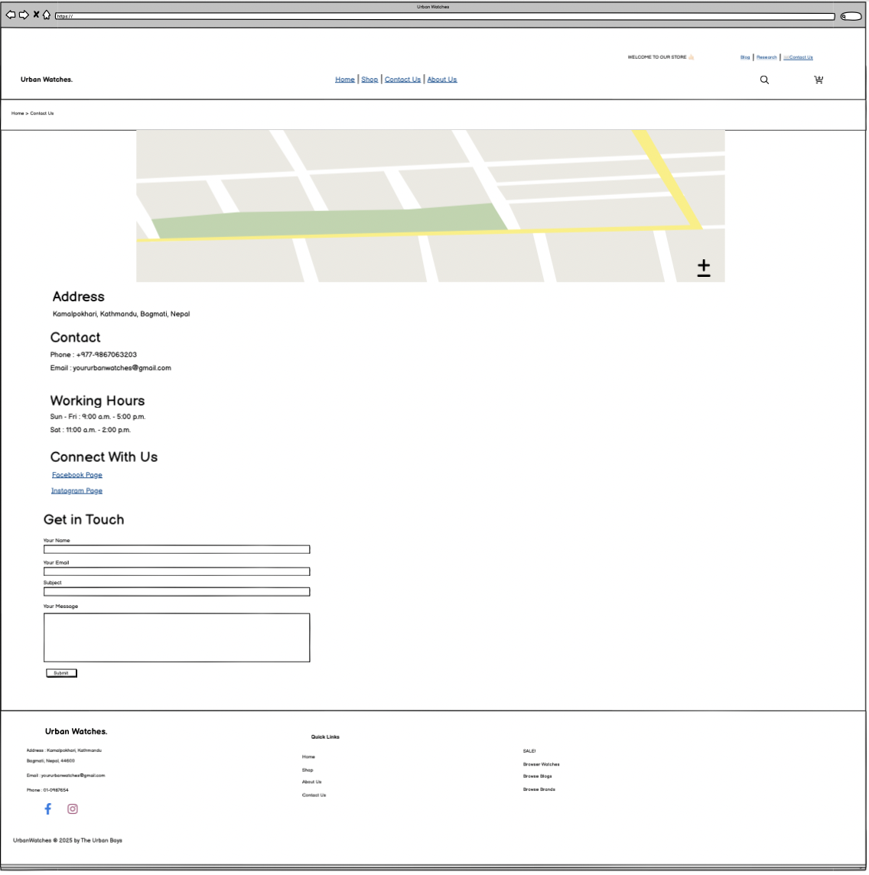

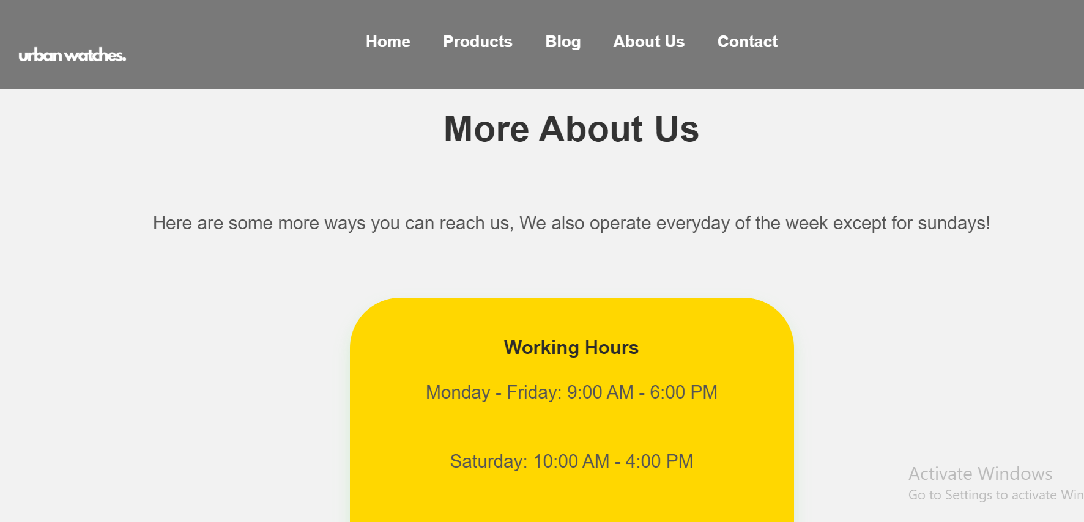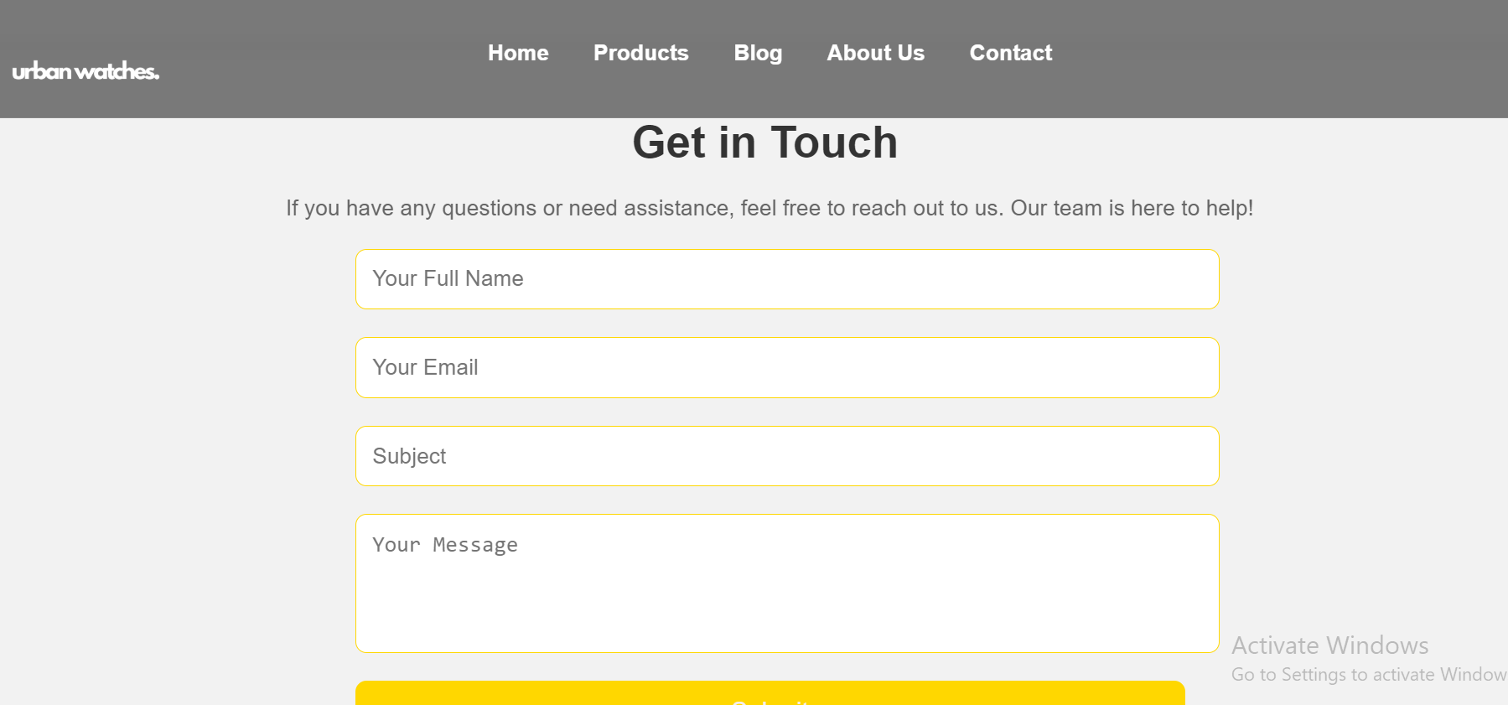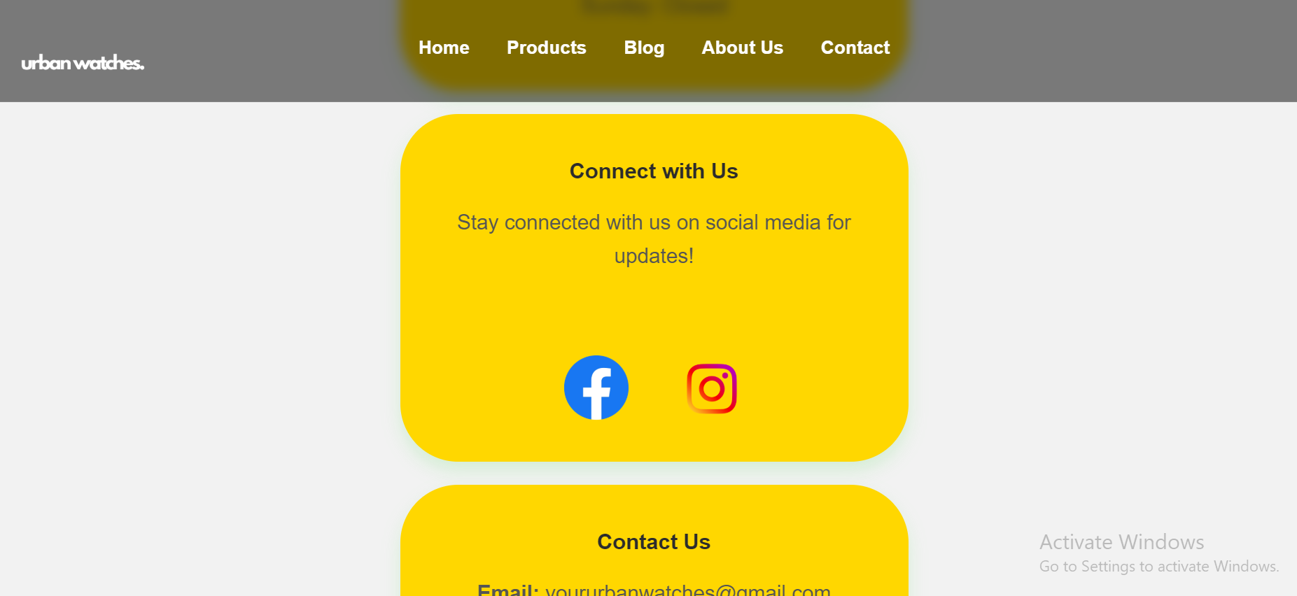

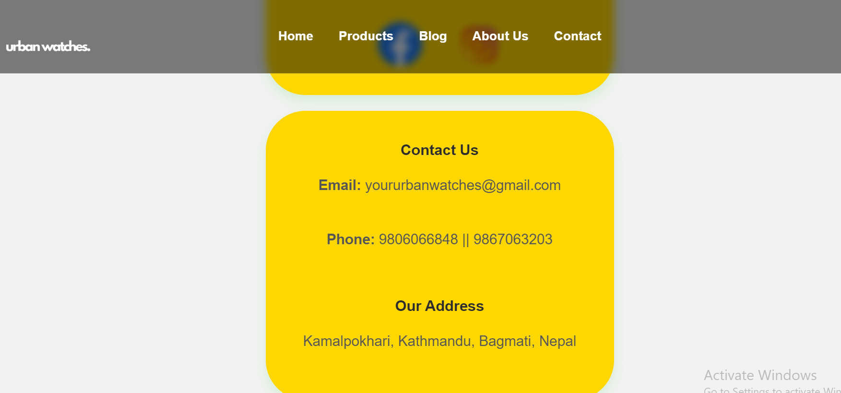

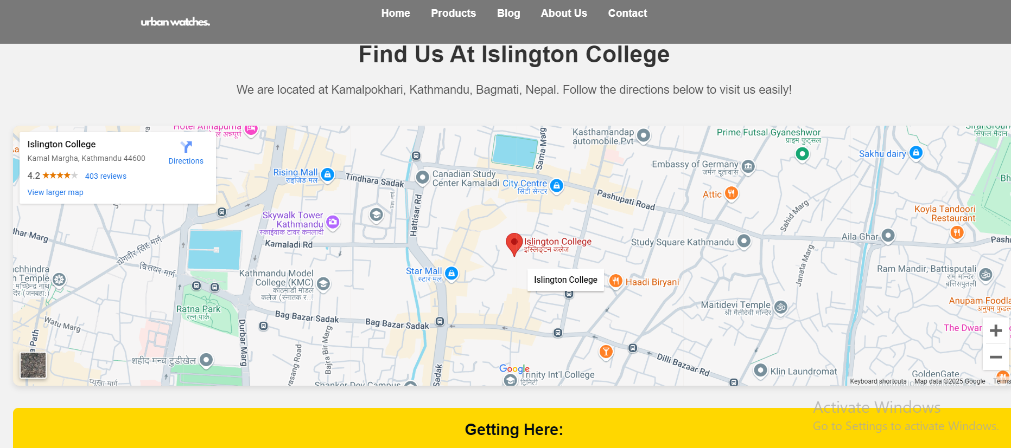

**RESEARCH PAGE:**

**WireFrame of Research Page:**

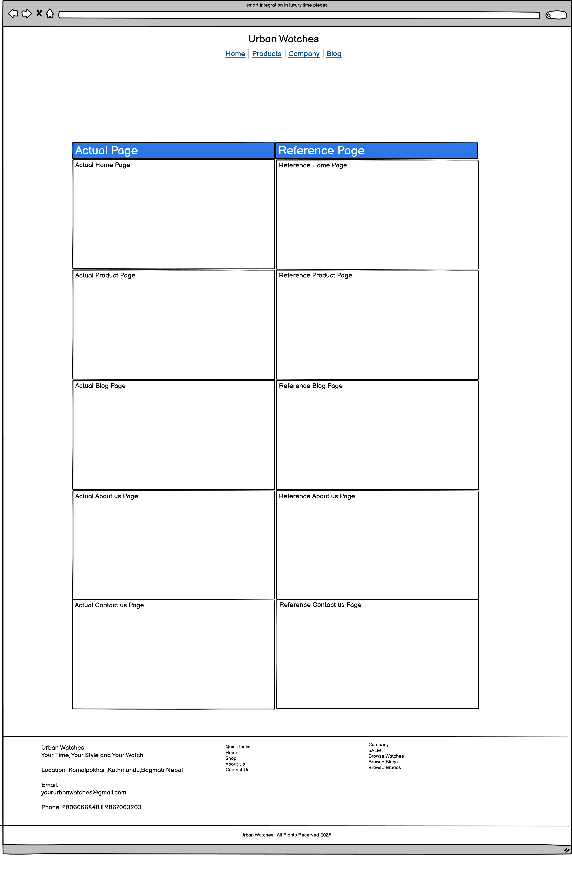

**Actual Research Page:**

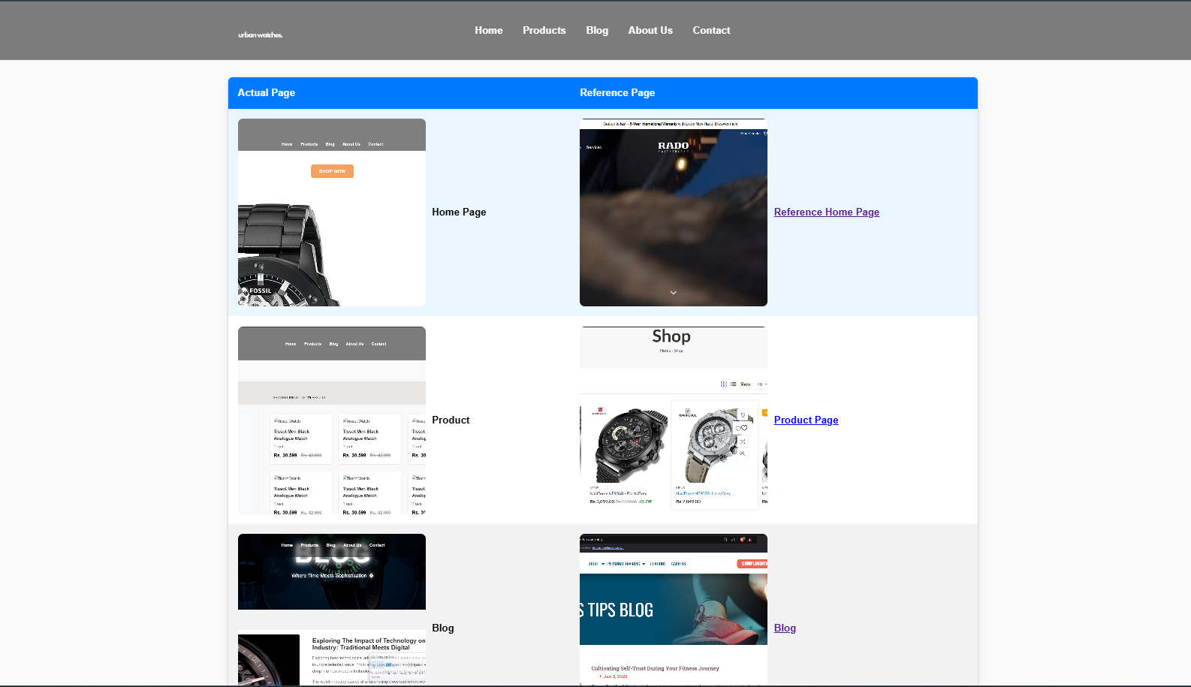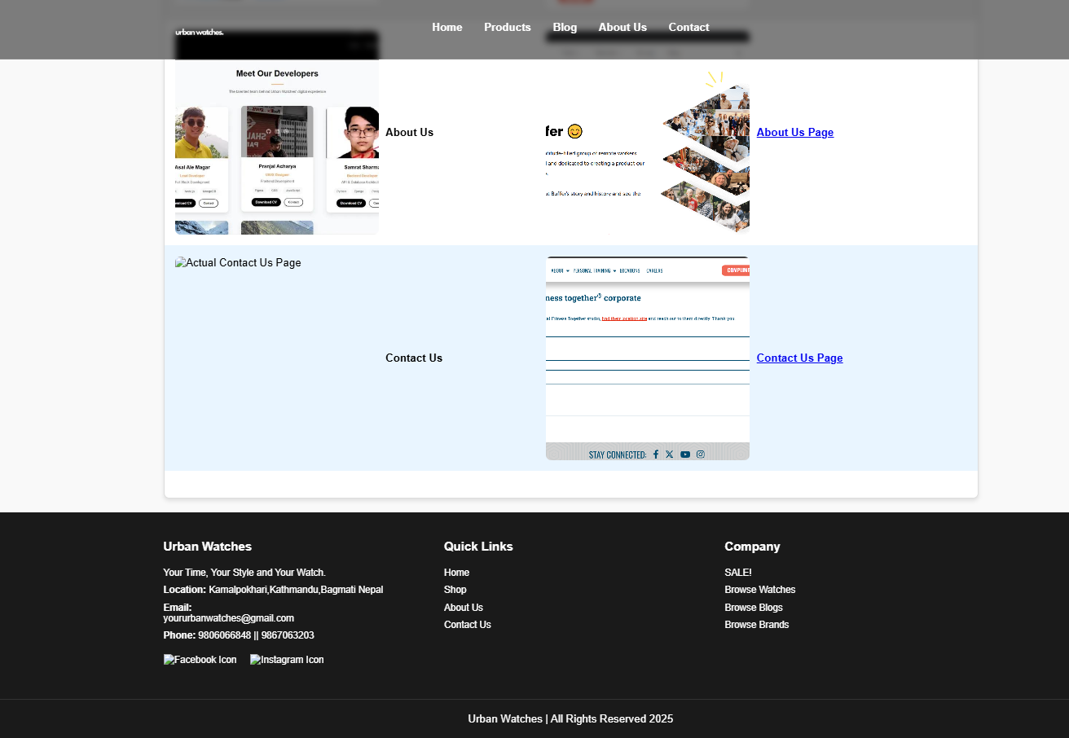

**3. Development**

HTML Tags Used Across All Pages

**Structural Tags**:

* <html>, <head>, <body>: Defines the main structure of each page.
* <header>, <footer>, <section>, <div>: Organizes content into different areas to make it easy to understand.

**Text Formatting**:

* <h1>, <h2>, <h3>, <h4>: Used for headings and subheadings.
* <p>: Used for paragraphs.
* <ul>, <li>: Used for lists, like showing features or trends.

**Media Tags:**

* <img>: Adds images to the pages and uses src for the image file and alt for accessibility.

**Navigation:**

* <a>: Creates links to other pages or sections, with href for the link and target for opening links in new tabs.

**Table Tags:**

* <table>, <thead>, <tbody>, <th>, <td>: Used to show comparison data and features in a table format.

**Metadata:**

* <meta>: Sets character encoding (charset="UTF-8") and ensures the website is responsive (name="viewport").

CSS Features Used

* Global Styling:
* *: Resets margins and padding to make the design consistent.
* body: Sets the base font style, background color, and overall look of the page.

**Layout and Positioning:**

* Flexbox: Helps arrange content in rows or columns and align items.
* Grid: Creates grids for a neat and organized layout.
* Padding, margins, and border-radius: Adds space around elements and smooth edges.

**Typography:**

* Fonts: Specifies font type, size, and weight.
* Text Effects: Adds colors and aligns text to make it stand out.

**Tables:**

* Borders: Makes table rows and columns visible and adds space inside cells.
* Header Styling: Makes table headers look different with background colors and bold text.

**Background and Media:**

* background-color and background-image: Adds colors or images behind sections.
* object-fit: Ensures images keep their proportions.
* Responsive image sizes using width and height.

**Responsive Design:**

* Media Queries: Changes the layout for tablets (max-width: 768px) and phones (max-width: 480px).
* Stacks content vertically on smaller screens.

**Specific Features:**

* Custom styles for lists, stats, and boxes on subpages.
* Hover effects on links to make them interactive.

.

**4. Content/Design**

Home Page

* Provides an introduction to the store and highlights featured watch collections.
* Includes navigation links to other sections.
* The name of the company with its motto is included.
* A division is included that contains trending products as well as short content of blog page.

**Products Page**

* Displays watches with relevant details like name, price, and descriptions.
* Features high-quality images and options for customer reviews.
* In the head, navigation bar is located.

**Blog Page**

* Explores industry trends and the impact of technology on watchmaking.
* Links to detailed articles for further reading in detail about the topic that has been asked.

**Research Page**

* Compares the website’s features with other e-commerce platforms.
* Highlights unique functionalities that enhance user experience.
* Clicking on the evidence, the user is directed towards the actual websites from where the reference is taken.

**About Us Page**

* Introduces the team members involved in the website's development.
* Includes profiles with technical skills, education, and contributions.
* There are 5 boxes with each member and their pictures.
* In about us page, CV of each developer is also presented.

**Contact Us Page**

* Contains form validation with external link to Google Maps.
* Shows the social media handles and detail info about the brand.

**Design Considerations**

* Responsive layouts ensure compatibility across devices.
* High-quality images enhance visual appeal.
* Semantic HTML improves accessibility and SEO.

**5. Testing**

**Test Cases**

1. **Test Case I: Page Works on All Screens:**
   * Checked how the layout adjusts on phones, tablets, and desktops.
2. **Test Case II: Navigation Works Properly**:
   * Made sure links between pages work smoothly.
3. **Test Case III: Content is Clear:**
   * Checked if the text, images, and headings are aligned and easy to read.
4. **Test Case IV: Links are Functional**:
   * Tested all links to ensure they go to the right places.
5. **Test Case V: Browser Compatibility:**
   * Confirmed the site looks the same in Chrome, Firefox, and Safari

**6. Conclusion**

**Summary**

Initially, wireframes were created for every webpage which ensured proper planning and design of the website using Balsamiq. VS Code text editor was uses. Basic structure of every web page was created using HTML. CSS was used to create the flexbox layout and style every minute detail throughout the website. JavaScript was used for form validation, image slider and pop ups. The sequential process of building the front-end part of the website was majorly highlighted throughout the creation of this project. Understanding how every internet technology works, a new insight to the world of web development was developed. Testing and report writing helped in proper documentation of a project This web project successfully combines good design with modern features. The home page and product sections are easy to use. The blog section provides useful tech updates. The research page shares valuable information about the company's work. The About Us page effectively tells the company's story. The website navigation works smoothly across all pages. The overall design maintains consistency and professionalism throughout.

**Lessons Learned**

* Improved skills in responsive design and semantic HTML.
* Gained insights into industry-specific content creation.

**Challenges**

→ Blog page:

Ensuring proper spacing between these containers while maintaining responsiveness across different screen sizes required multiple iterations and testing. Another significant challenge was implementing smooth hover effects and transitions for the containers without disrupting the overall layout. Managing the content overflow within the containers and maintaining consistent heights also proved to be time-consuming tasks. The integration of images within these containers while keeping the loading times optimal required careful optimization.

**Suggestions for Improvement**

* Enhance interactivity with animations and transitions in future iterations.
* Adding more animations in the Home Page.

**7. References**

[List references here in proper citation format.]

**8. Appendices**

**HTML and CSS Files**

* Full code for the main blog page and subpages.
* Comments included for clarity and maintainability.